GITLAB Runner Configuration:

Runner can be matched as Slave Agent in Jenkins or SelfHosted Agent in Azure DevOps.

1. We can create runners anywhere we need, even we can make your laptop/desktop a runner as well.
2. You can use AWS or Azure Ubuntu or Windows machine as a Runner.
3. Create Ubuntu 20.04 in AWS and download Terraform to it.
4. Go to Project -> Settings ->CI/CD -> Expand Runners.
5. Download Agent from https://docs.gitlab.com/runner/install/linux-manually.html
6. curl -LJO "https://gitlab-runner-downloads.s3.amazonaws.com/latest/deb/gitlab-runner_amd64.deb"

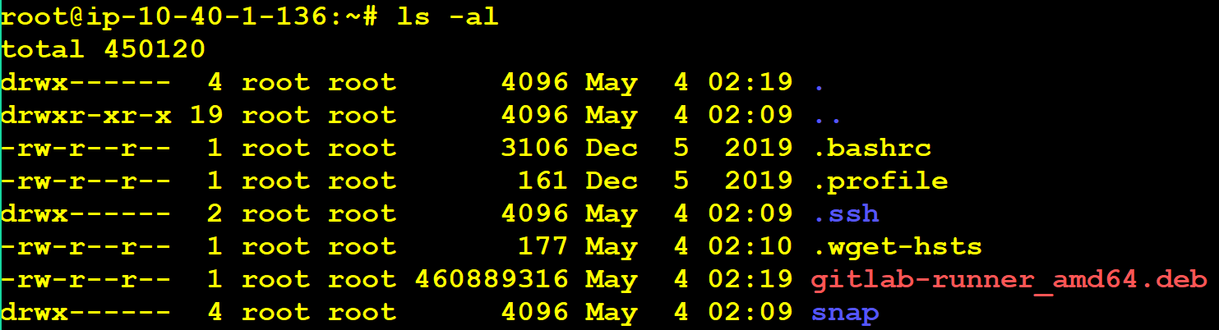

1. Install Package by running below command

dpkg -i gitlab-runner_amd64.deb

1. Check the Gitlab Runner Service running using below command:

ps -ef | grep -i gitlab



1. Register the runner with Gitlab.

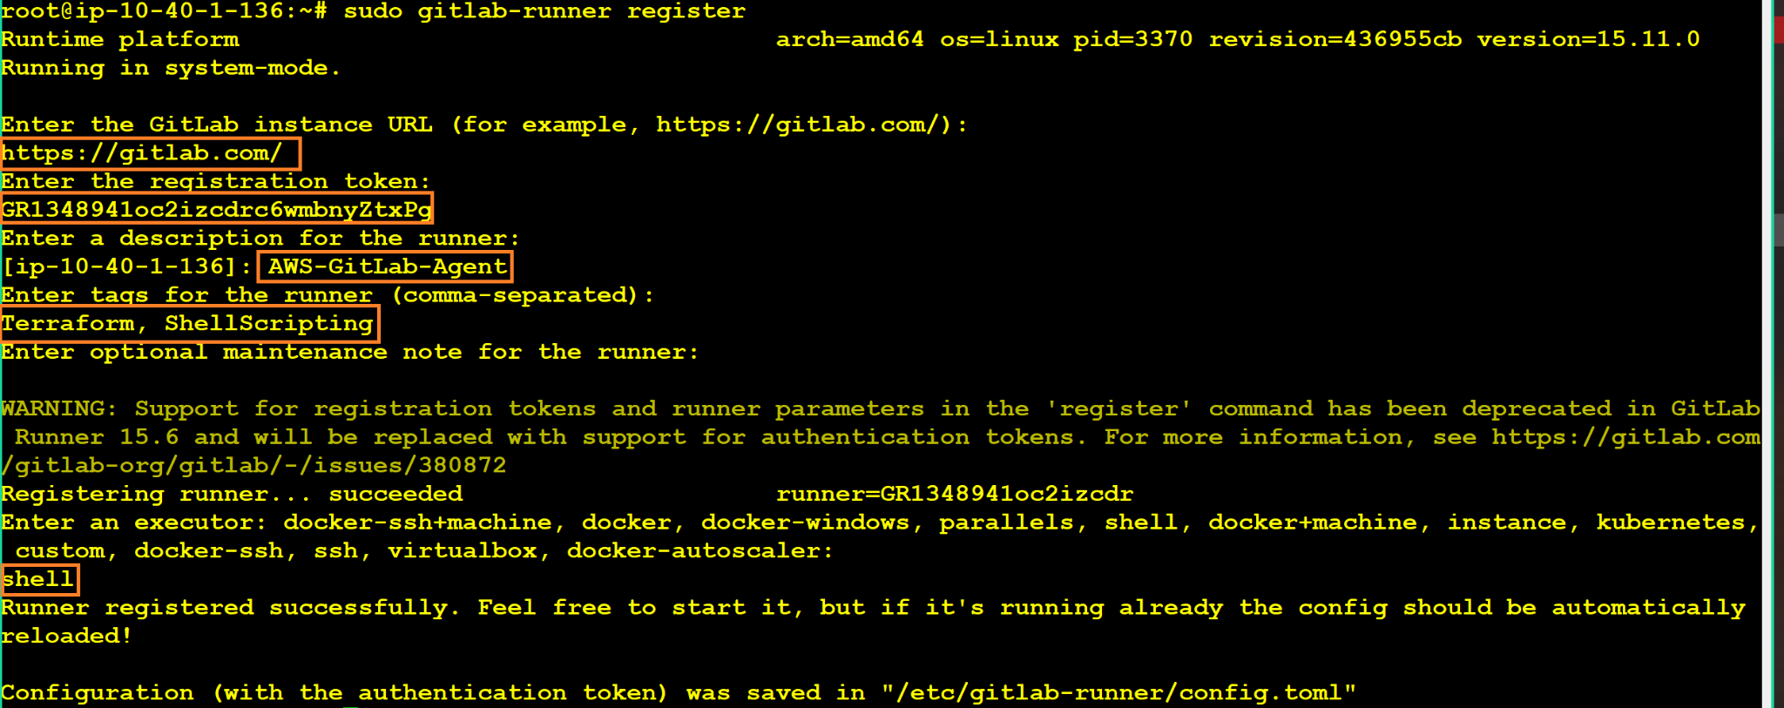

1. Check the status in GitLab Console:

